EXTRACTIVE INDUSTRIES
TRANSPARENCY INITIATIVE
OF THE REPUBLIC OF ARMENIA

OPEN DATA POLICY
DECEMBER, 2017

Open Data in the EITI context

The willingness of the Government of the Republic of Armenia to implement the Extractive Industries Transparency Initiative (EITI) was announced by the Prime Minister of Armenia on July 28, 2015. The primary aim of the EITI implementation is to ensure transparent and accountable management of the country's mining sector.
As a result of the EITI Standard implementation, it is envisaged to collect and process large-scale information about the mining sector of the country, and make it available to the general public. The scope of that information should be approved by the EITI Multi-Stakeholder Group (MSG) in accordance with the requirements of the EITI Standard, national EITI priorities and national context. Nevertheless, the MSG admits that it is possible that even public availability of content-rich and up-to-date information may not be enough to secure the ultimate goal of awareness raising and implementation of reforms in the mining sector.
Henceforth, in terms of providing real transparency, the MSG gives emphasis not only to the issues of the content of data but also the form and means of its accessibility.
Based on the above, the Armenian MSG defines the open data principles within the framework of the EITI implementation in Armenia and expresses its commitment to be consistent in their application.
The Open Data Principle is applicable to public data and information within the scope of the EITI in accordance with the Constitution of the Republic of Armenia, international treaties, legislation of the Republic of Armenia, the EITI Standard and this Policy.
The application of the Open Data Principle is perceived in parallel with the publication of the EITI National Reports, and does not oblige reporting entities to apply it, however the EITI stakeholder entities are encouraged to be guided by the Open Data Principle when publishing relevant data.

Open data is data that can be freely used, re-used and redistributed by anyone, naming the author.

EITI Standard Requirements for Application of the Open Data Principle

The 7.1 requirement of the EITI Standard establishes that the Multi-Stakeholder Group is required to:
- Agree a clear policy on the access, release and re-use of EITI data. Implementing countries are encouraged publish EITI under an open license, and to make users aware that information can be reused without prior consent.
- Make the EITI Report available in an open data format (xlsx or csv) online and publicise its availability.
The 7.2 requirement of the EITI Standard encourages the Multi-Stakeholder Group to make EITI Reports machine readable, and to code or tag EITI Reports and data files so that the information can be compared with other publicly available data by adopting Board-approved EITI data standards.

Objectives
The objective of the publication of data in the scope of the EITI based on the Open Data Principle is to provide greater transparency in the Armenian mining sector, to achieve the EITI national objectives, as well as to promote participatory governance, innovation and sustainable development.
Access to information corresponding to the Open Data Principle can provide individuals, civil society, media, business and academic institutions with information about the mining industry and form an informed debate.

EITI Open Data Principles

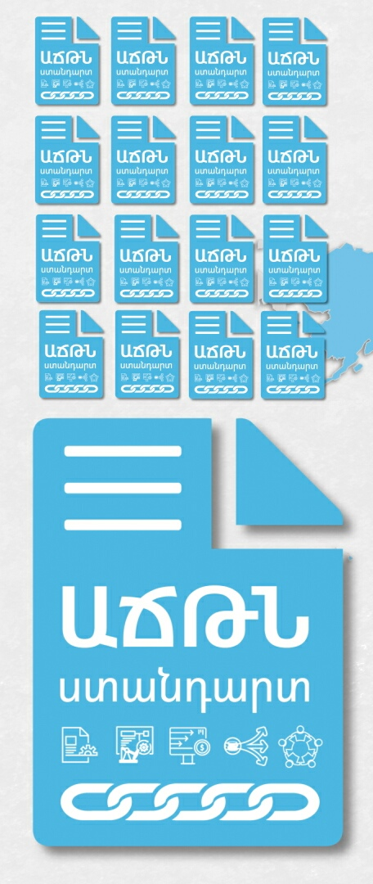
This Policy defines the main principles for the publication of data collected in the scope of the EITI. In each reporting period, the MSG decides on the scope of the data covered by the EITI National Report, as well as on publication of that data in open data formats, in accordance with this Policy.
Data Completeness
The data published within the scope of the EITI should be as complete as possible. All the raw data should be made available to the public unless it contradicts the legislation. The metadata that describes the raw data including the methodology and formulas used for calculations shall be made available as well. The MSG decides which data are subject to publication.
Data Sources
Data sources, as well as information from where and how these data were acquired should be made available. This will allow the user to make sure that the information has been obtained and recorded adequately.
Data timeliness
The data collected within the scope of the EITI should be accessible to the public within a reasonable time and without irrational delays. Priority is the timely publication of the data, usefulness of which is essentially dependent on the time factor.
Data accessibility
The information published by the EITI should be as accessible as possible, in terms of searchability, the ability to easily find and download.
Machine readability
Some data formats are easily read by programs and machines. Therefore, the EITI data should be published in such formats (for example, xls, csv, xml, or docx).
Non-discriminative use
Each individual should have access to the information published within the scope of the EITI without having to identify themselves or having to provide justification for the use of data.
Data sustainability
The data should be available for a long period of time. This means that data must be stored in online archives. The official website of the EITI Armenia should ensure the EITI data storage stability and persistence of its accessibility.
The use of open licence
The information published within the scope of the EITI can be freely used by everyone, provided that it is clearly marked as a work of the EITI Armenia.
Free use of Data
The information within the scope of the EITI national reports should be available free of charge.
Feedback
Feedback mechanisms should be provided for users whenever it’s possible, which also may help to ensure data quality continuous improvement.

Recommendations

The EITI National Secretariat of Armenia and the Armenian EITI MSG, when acting for achieving national EITI goals, will be guided by the open data principles set forth in this Policy while carrying out their activities, implementation of the EITI Work plan, publication of the EITI national reports, and provision of information and data within the scope of the EITI. The EITI National Secretariat of Armenia and the Armenian EITI MSG will encourage relevant state bodies and other stakeholders to be guided by the Open Data Principle as well.
The EITI National Secretariat of Armenia and the Armenian EITI MSG, while designing the terms of reference of the EITI Armenia’s official website (portal) and during website’s management, will be guided by the open data principles, so that the information provided on the website is accessible to the user in terms of searchability, easy access, use and download.

